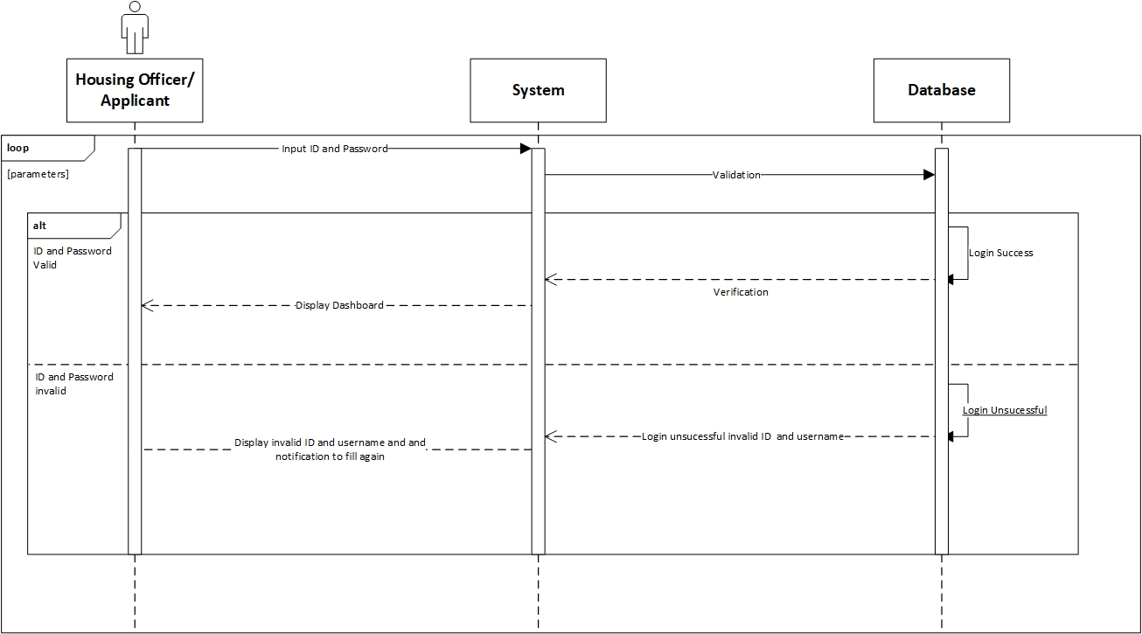

|  |  |
| --- | --- |
| **Cross References** | **Login** |
| Operation | Login with ID and username |
| Responsible | To access the main page |
| Pre-conditions | * Username must be available * Password must be available |
| Post-conditions | * Username is matched * Password must be match based on user’s password input * Display dashboard |

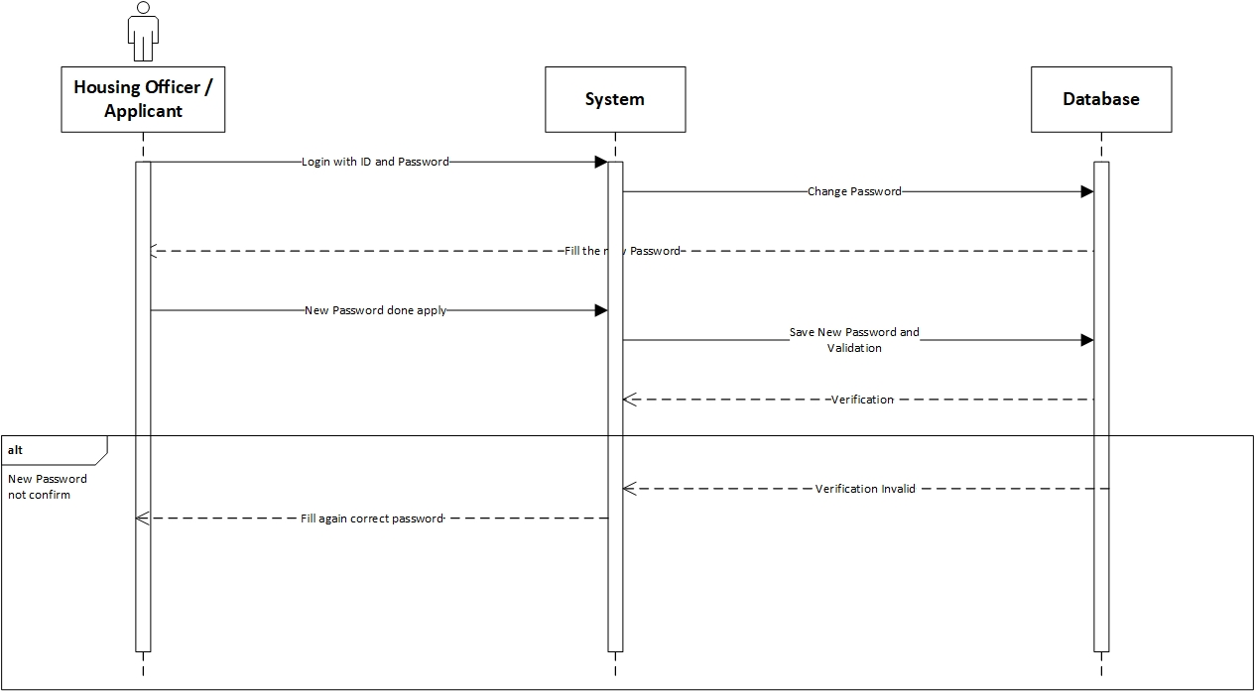

|  |  |
| --- | --- |
| **Cross References** | **Change Password** |
| Operation | Enter current password |
| Responsible | To change the password |
| Pre-conditions | The new password must be available |
| Post-conditions | Successfully changed password |

|  |  |
| --- | --- |
| **Cross References** | **Change Password** |
| Operation | Enter current password |
| Responsible | To change the password |
| Pre-conditions | The user must be enter the new password again to confirm |
| Post-conditions | Fill again the form with the new password |

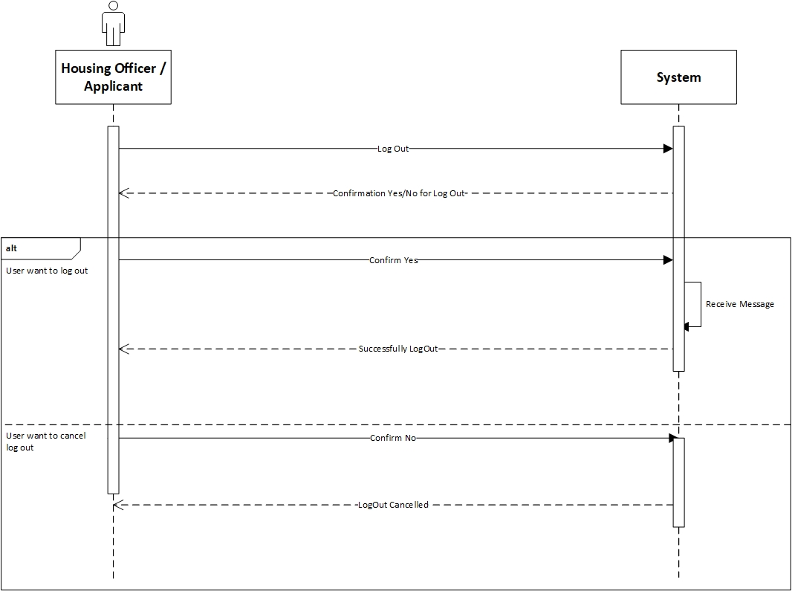

|  |  |
| --- | --- |
| **Cross References** | **Log Out** |
| Operation | User want to log out |
| Responsible | To log out from the system |
| Pre-conditions | The user accepts that they want to log out |
| Post-conditions | Successfully log out |

|  |  |
| --- | --- |
| **Cross References** | **Log Out** |
| Operation | Cancel to log out |
| Responsible | To cancel log out from the system |
| Pre-conditions | The user cancel log out by click the “No” option |
| Post-conditions | Log out cancel |

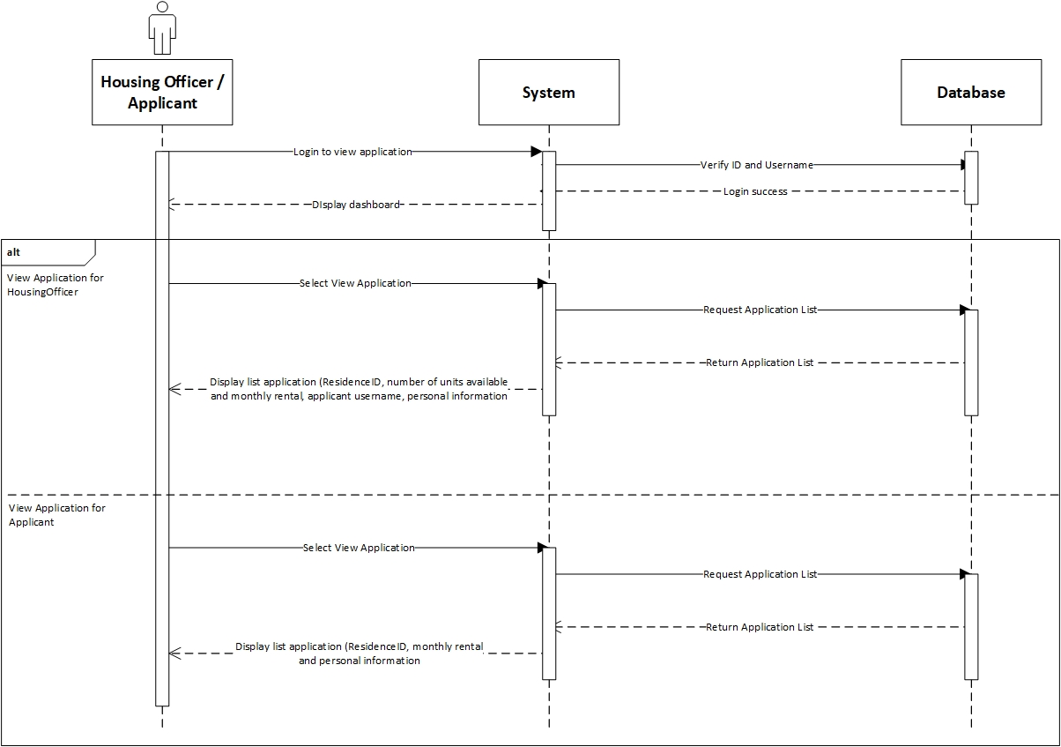

|  |  |
| --- | --- |
| **Cross References** | **View Applications** |
| Operation | Login with username and password |
| Responsible | To get access to view the applications |
| Pre-conditions | * Username must be available * Password must be available |
| Post-conditions | * Username is matched * Password must be match based on user’s password input * Display dashboard |
| **Cross References** | **View Applications** |
| Operation | View Application in Housing Officer |
| Responsible | To view a list for the Residence that Housing Officer is responsible |
| Pre-conditions | The application object must be available |
| Post-conditions | The list of application with status for the Residence that the Housing Officer is responsible, showing the residence ID, number of units available, monthly rental, application username and personal information |
| **Cross References** | **View Applications** |
| Operation | View Application in Applicant |
| Responsible | To view a list of application that have been made for applicant |
| Pre-conditions | The application object must be available |
| Post-conditions | The list of application that have been made by the applicant, showing the residence ID, monthly rental and personal information |

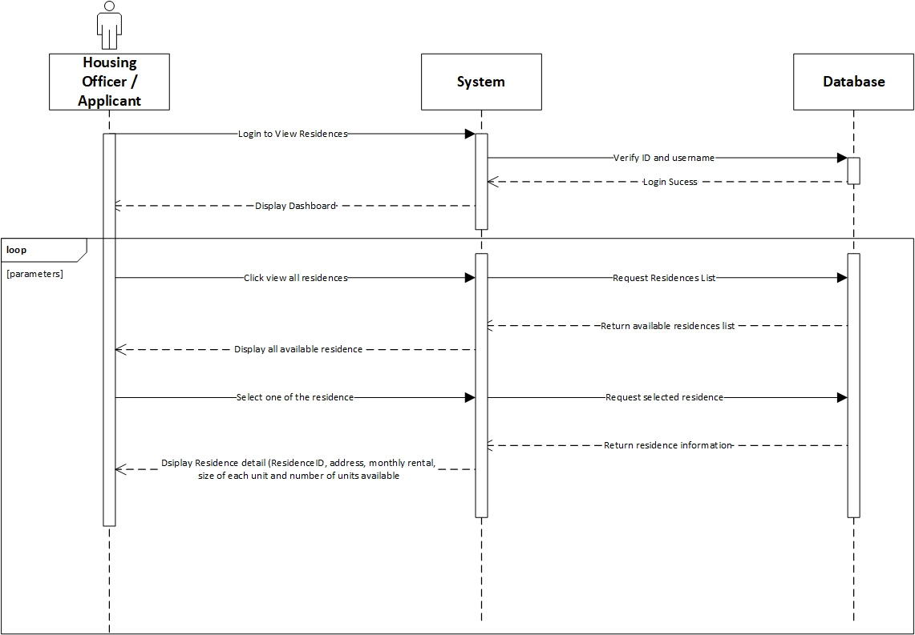

|  |  |
| --- | --- |
| **Cross References** | **View Residences** |
| Operation | Login with ID and username |
| Responsible | To access the main page |
| Pre-conditions | * Username must be available * Password must be available |
| Post-conditions | * Username is matched * Password must be match based on user’s password input * Display dashboard |

|  |  |
| --- | --- |
| **Cross References** | **View Residences** |
| Operation | Click view all residences |
| Responsible | To get all list of the residences |
| Pre-conditions | The residence object must be available |
| Post-conditions | Success to display all residences of all residences |

|  |  |
| --- | --- |
| **Cross References** | **View Residences** |
| Operation | Select the residence to view |
| Responsible | To get information about selected residences |
| Pre-conditions | The residence ID must be available |
| Post-conditions | Success to display detail information about the selected residences |

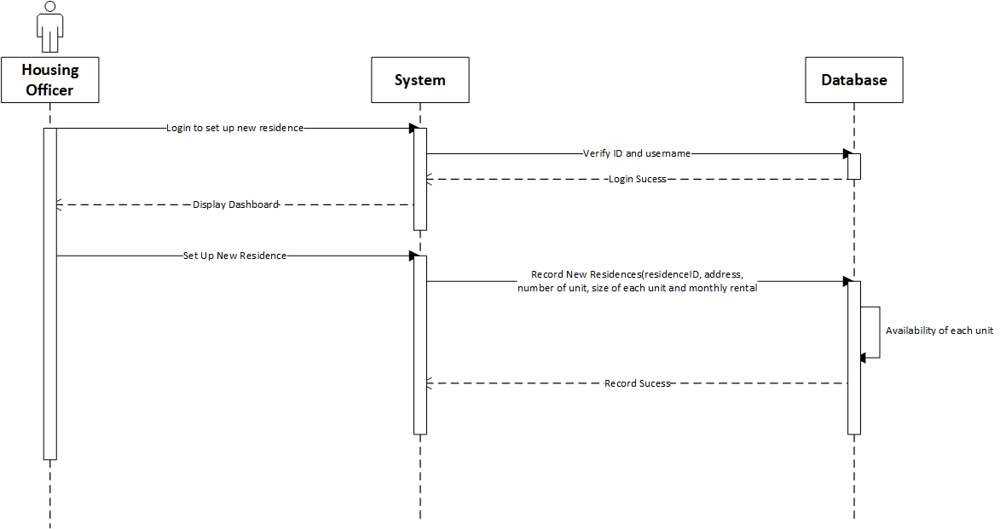

|  |  |
| --- | --- |
| **Cross References** | **View Residences** |
| Operation | Login with ID and username |
| Responsible | To access the main page |
| Pre-conditions | * Username must be available * Password must be available |
| Post-conditions | * Username is matched * Password must be match based on user’s password input * Display dashboard |

|  |  |
| --- | --- |
| **Cross References** | **Set Up New Residences** |
| Operation | Set up new residences |
| Responsible | To set up the new residences by input the residenceID, address, number of units available, size of each unit and monthly rental |
| Pre-conditions | Object residenceID, address, number of units available, size of each unit and monthly rental must be available |
| Post-conditions | New residences was successfully added to the system |

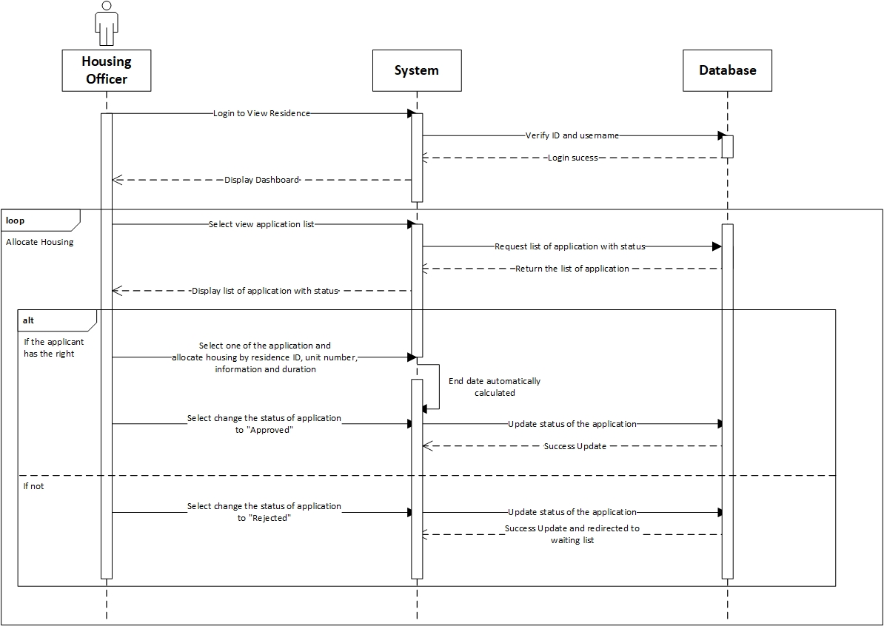

|  |  |
| --- | --- |
| **Cross References** | **View Residences** |
| Operation | Login with ID and username |
| Responsible | To access the main page |
| Pre-conditions | * Username must be available * Password must be available |
| Post-conditions | * Username is matched * Password must be match based on user’s password input * Display dashboard |

|  |  |
| --- | --- |
| **Cross References** | **Allocate Housing** |
| Operation | Select view application list |
| Responsible | To get the list of all application |
| Pre-conditions | The application object must be available |
| Post-conditions | Success displayed list of all application with status |

|  |  |
| --- | --- |
| **Cross References** | **Allocate Housing** |
| Operation | Select one of the application and allocate the housing |
| Responsible | To allocate the housing for an application |
| Pre-conditions | Object residenceID, unit number, from date and duration must be available |
| Post-conditions | Success create allocation object based on data input |

|  |  |
| --- | --- |
| **Cross References** | **Allocate Housing** |
| Operation | Select to changed status of to be “Approved” |
| Responsible | To change the status to “Approved” |
| Pre-conditions | Application object must be available |
| Post-conditions | Success changed the application status |

|  |  |
| --- | --- |
| **Cross References** | **Allocate Housing** |
| Operation | Select to changed status of to be “Rejected” |
| Responsible | To change the status to “Rejected” |
| Pre-conditions | Application object must be available |
| Post-conditions | Success changed the application status and redirected to waiting list |